**SCREENSHOTS OF CODES OF ASSIGNMENT 2 :**

**Q1:**

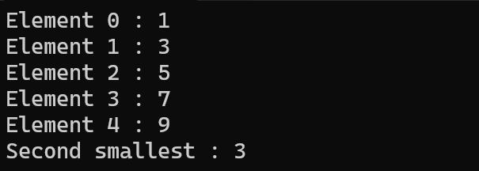

**Q2:**

**Q3:**

**Q4:**

**Q5:**

**Q6:**

**Q7:**

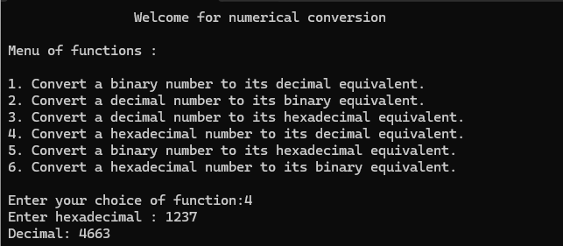

**Q9:**

**Q10:**

